Task No & Title: Unit 14 | Unit Descriptor Unit Descriptor This unit describes the performance outcomes, skills and knowledge required to use digital camera technology for theproduction of colour separated images.
Title: | Capture a digital image
Suitable for Classes: | Certificate II in Information Technology
Area: | Technology & Enterprise
Teacher: | Mr Peter Faulks
Timeline | 1 Lesson
Date Due: | Today

Task Brief:

Files Required

Items highlighted in yellow are tasks for you to complete
Items in Purple are help tips
Certificate II in Information Technology
Capture a digital image
1 | ICAU1128B Operate personal computer | Pre | 20 hours
2 | BSBCMN106A Follow workplace safety procedures | Core | 10
3 | ICAD2012B Design organisational documents using computing packages | Core | 40
4 | CAU2005B Operate computer hardware | Core | 20
5 | ICAU2006B Operate computing packages | Core | 60
6 | ICAU2013A Integrate Commercial computing packages | Core | 25
7 | ICAU2231B Use computer operating system | Core | 20
8 | ICAW2001B Work effectively in an IT environment | Core | 25
9 | ICAW2002B Communicate in the workplace | Elective | 20
10 | ICAS2014B Connect Hardware Peripherals | Elective | 25
11 | ICAU2007B Maintenance of equipment and consumables | Elective | 15
12 | ICPMM263B Access and use the internet | Elective | 20
13 | ICAW2011B Work individually or as a team member | Elective | 20
14 | ICPMM321B Capture a digital image | Elective | 30

There are several file types used to store images. Most of these file types compress the image; The more often you edit and save, the more degraded the image will be.
Photographs are best saved as JPEG images. To gain a fuller understanding of manipulating images try the following:
Select a digital photograph and try saving the image at different levels of compression. Your aim is to get the best balance between file size and image quality. Compare the file sizes and qualities of each saved image and then answer the following questions.
- At what point in compression does the JPEG become too poor to use on a web page? Is that point the same for all the photos you experimented with? Answers will vary
- How do the GIF and JPEG files compare in quality and file size? What conclusions can you draw?

Answers will vary
- Create a graph comparing the JPEG file sizes against the different compression levels. Describe the trends. What conclusions can you draw?

Answers will vary
- Create a table comparing and contrasting the following graphic file formats: BMP, GIF, JPEG and PNG. In your table include information on uses, colour, compression, size, lossy, advantages and disadvantages.

- Answers will vary
Use the internet and reference books to find all the information. The following web sites have some useful information on images.
  - www.wotsit.org .
  - http://graphicsoft.about.com
You need to include some graphics in an electronic presentation on the World Wide Web. The software program you are using only allows the graphic file formats: JPEG, GIF and PNG. The following two graphics of the same resolution are very different. Suggest the most appropriate format to use for each graphic, photo, rabbit and penguin and provide reasons for your choice.

Graphic 1 is Full colour photograph | Graphic 2 is a black and white line diagram
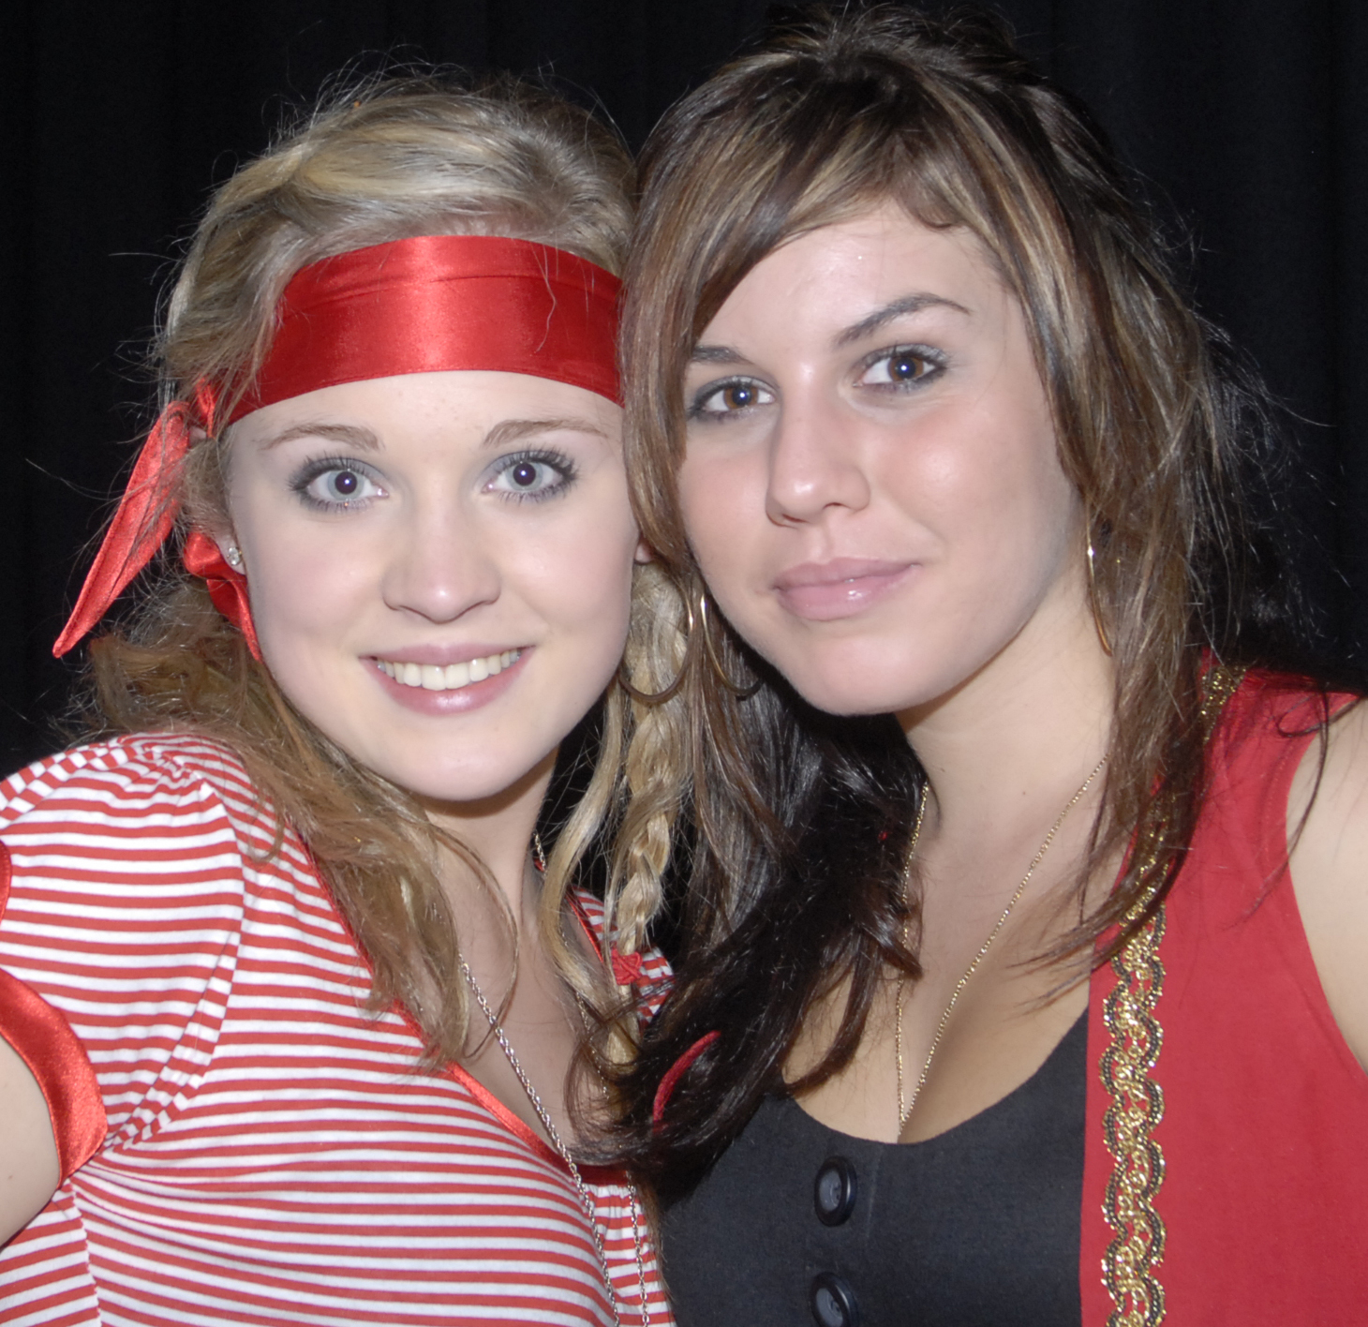 | 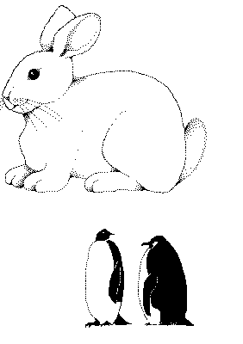

- Graphic 1
  - Format = jpeg, at resolution 72dpi suitable for web
- Reasons = This format supports photos, particularly images with blocks of colour. This format compresses colour better and retains a high degree of colour fidelity. This format has a smaller compression size.
  - Graphic 2 Rabbit
  - Format = pgn with transparent background
  - Reasons = can be used on web page or body can be coloured in or shaded
- Graphic 3 Penguin
  - Format = gif or png as both are suitable for web pages
  - Reasons Image is black and white and the format that best suits this image. GIF supports transparency. In this case, the background is clear. GIF maintains resolution and sharpness, even when compressed, however png 24 is probably the better option for transparency to web.

  - You might like to discuss your answers with your teacher or compare results with fellow students.

Design organisational documents

Activity 1 answers
File Format | BMP  Bitmap | GIF  Graphics Interchange Format | JPEG  Joint Photographic Experts Group | PNG  Portable Network Graphics
Uses | Pattern of pixels or tiny coloured dots. | Web graphics. Ideal for graphics that use only a few colours. Used for bitmap images – line drawings or blocks of a few distinct colours. | Web graphics. Photographs & scanned photos. Images with few distinct colours – illustrations, cartoons, icons & images with blocks of colour. | Web graphics. Single images only.
Colour | Fixed colour palette. | Maximum 256 colour. | True colour 24 bit graphics. Capable of displaying 16.7million colours. | True colour palette and grey scale. 16 million colours.
Compression | Not supported. | Highly compressed – no loss of data. | Smaller than GIF, less compression but better image quality. | 10 – 20% more than a GIF. No loss of data.
Size | Very large. |  | Highest quality – largest file.  Smaller files – reduced quality.
Lossy | No. | Yes – no image quality lost. | Yes. | No.
Advantage | Good for small picture graphics & basic logos. | Can be transparent. Maintains resolution and sharpness even when compresses. Supports animation. | Compresses colour better and retains a high degree of colour fidelity. Can look almost as good as a photo. | Will eventually replace GIF. Platform independent. Greater colour support and better compression. Better support for transparency.
Disadvantage | Large file size. | Loses quality with high resolution pictures. Not effective for detailed photographs. | Not good with straight lines. Smaller file size the more picture info is lost & further away from original. Does not support transparency. | Doesn’t support animation. New format, so only recent browsers can display PNG graphics.

Reference
http://hsc.csu.edu.au/info_tech/compulsory/documents/3553/activity1.htm

Student Name: | Date submitted:
I declare this evidence to have been produced by me the undersigned.

Candidate’s signature:
Title of Portfolio evidence presented (include Unit No and section i.e. 03.05)
:-
□ Outcomes from learning programs (including self-learning and online learning)
□ Assessment feedback (from a trainer or assessor)
□ Observation checklists (from a workplace supervisor or assessor)
□ Written statements or references (including workplace supervisors, community leaders)
□ Job descriptions
□ Work journal
□ Work samples
□ Finished products
□ Product descriptions or specifications (supporting the product samples included)
□ Statutory declarations
□ List others (or delete any from above not provided)
- All work submitted to be word processed and spell checked.
- There must be at least two samples of evidence for each
Element within the Unit of Competency. This is sample 1 / 2
- All work submitted must be of a high quality and meet the
requirements of the Unit of Competency.
Other evidence (List each piece):
Assessor to complete
Evidence is Valid Sufficient Authentic Current
□ □ □ □

Assessor signature: _________________________________Date: _____________
Peter Faulks, BA Soc Sci, Grad Dip Ed, Cert IV AWT
Certificate II in Business assessor/teacher
Assessor to complete

Student is declared Competent Not Yet Competent
□ □

Keep a copy of this report with your file for evidence

